Pakistan J. Zool., vol. 43(3), pp. 523-527, 2011.

Identification of Fossil Corals Inhabiting an Uplifted Area of Ras Gunz Near Jiwani, Balochistan, Pakistan

Pirzada J.A. Siddiqui,¹ Amjad Ali,¹* Kate Bromfield,² Pervaiz Iqbal¹ and Nafisa Shoaib¹
¹Center of Excellence in Marine Biology, University of Karachi, Karachi 75270, Pakistan
²ARC Centre of Excellence in Ore Deposits, School of Earth Sciences, University of Tasmania, Private Bag 126, Hobart, Tasmania 7001. Australia

Abstract.- Jiwani is located about 720 km from Karachi and 60 km from Gwader towards the west (25º 02’ 610” N & 61º 44’ 438” E) on the Balochistan (Makran) coast. The Balochistan coast is comprised of deformed and faulted sediments ranging from the Cretaceous to the Recent periods. The coastline has been raised about 500 m during the mid-Pleistocene to Recent, and a number of fossil mollusks and corals are found embedded in a variety of lithostratigraphic units. The present study identifies fossil corals collected from Ras Gunz, near the main fishing village at Jiwani. Fourteen species of fossilized corals belonging to 2 families and 8 genera were identified and compared with the current distribution of coral species along the coast of Pakistan.

Key words: Balochistan coast, fossil corals, uplifted.

INTRODUCTION

Jiwani is located on the Balochistan coast of Pakistan (25º 02’ 610” N & 61º 44’ 438”E) at about 720 km from Karachi and 60 km from Gwader towards the west. In general, about 800 km long Balochistan coast is considered a subduction zone and is comprised of deformed and faulted sediments ranging from the Cretaceous to the Recent (Harms et al., 1984). The convergence and jostling of large continental plates has caused complex geotectonic activity. Harms et al. (1984) described the stratigraphic and tectonic history of the area including Balochistan coastal belt. The over all convergence and jostling of large continental plates have resulted in a complex geotectonic changes. These changes are categorized in three phases. The first phase (the middle Miocene) is dominated with turbidity current deposits. The second phase (late Miocene to mid Pleistocene) is characterized by progradation of slope, shelf and plains. Tectonically the area has been folded and uplifted in the landward margin. Events in the third phase (mid Pleistocene to recent) are marked with uplifting (up to 500 m) and faulting. The area is reported to have a number of fossil mollusks and corals embedded in
___________________________
* Corresponding author: aalimbku@hotmail.com
0030-9923/2011/0001-0523 $ 8.00/0
Copyright 2011 Zoological Society of Pakistan.
a variety of lithostratigraphic units (Crame, 1984; Ali and Memon, 1995).
The fossil coral assemblages in the uplifted lithostratigraphic units; for example, from Gawadar headland approximately at the height of 145 m above present sea-level, and Jiwani, have not previously been studied and the coral species remain taxonomically unidentified. Only a brief mention of common names of some corals is available in a previous report (Ali and Memon, 1995). Living corals are however distributed all along Balochistan coast, and at least 30 hard coral species and 8 soft coral species have been identified from various places along the coast, particularly Churna and the Astola Islands, where considerable living coral assemblages are found (Ali, 2008). The primary aim of the present study is to identify fossil coral species collected near Ras Gunz, the main fishing village at Jiwani, and to compare them with modern corals currently distributed along the coast of Pakistan.

MATERIALS AND METHODS

Fossil corals were collected randomly in August 2008 from uplifted Pleistocene age strata located several tens of meters above sea-level near Ras Gunz (25° 05’ 583” N, 61 51’ 439” E), the main fishing village at Jiwani (Fig. 1). Small pieces of coral samples were washed with fresh water for detailed examination of identifiable taxonomic features. The recorded specimens are archived at CEMB, University of Karachi for future reference. The overall and magnified images of individual samples were recorded using a high magnification Sony DSC- W 90 digital camera. The samples were identified on the basis of their primary (growth forms, corallites etc.) and secondary characters (columella characters) according to Veron (2000).

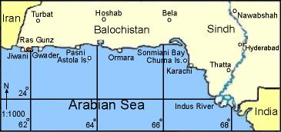

Fig. 1. Map of the Pakistan coast showing study site at Ras Gunz near Jiwani.

RESULTS

Species identification
A total of 14 specimens (Table I) of different types of corals were identified on the basis of primary and secondary characters. Detailed descriptions of each coral species examined are given below and species are shown in Figure 2.

Description of species
Favia truncatus?
Colonies are massive. The corallites are plocoid, compact, variable in size and deep. The size of the corallites ranges from 7 to12 mm in diameter. The septa are in two orders and widely spaced. Columella well developed with a crown of paliform lobes.

Favia lizardensis
Colonies are massive. Corallites are plocoid, rounded, Shallow, ranging from 5 to 10 mm in diameter and regularly spaced. Septa are fine and largely spaced. Columella parietal well, while pali poorly developed.

Favia sp.1
Colonies are massive. Corallites are strongly plocoid, variable in size, ranging from 7 to 15 mm in diameter. Corallites are exerted. Septa are numerous, in 3 orders, and slightly exsert. Costae well developed and joined to the adjacent corallite. Columella and pali well developed. The extrathecal surface is solid.

Table I.- Species of fossil corals, identified in Order Scleractinia and two families, collected from an uplifted location at Ras Gunz near Jiwani, Balochistan. Taxon with a question mark is not identified with certainty.

S. No. | Species | Family
1 | Favia truncatus? | Faviidae
2 | Favia lizardensis | Faviidae
3 | Favia sp.1 | Faviidae
4 | Favia sp. 2 | Faviidae
5 | Favia sp.3 | Faviidae
6 | Favia sp.4 | Faviidae
7 | Favites cf. acuticollis | Faviidae
8 | Favites sp. | Faviidae
9 | Goniastrea cf. retiformis | Faviidae
10 | Platygyra daedalea | Faviidae
11 | Cladocora cf. caespitosa | Faviidae
12 | Cyphastrea serailia | Faviidae
13 | Astreopora sp. | Acroporidae
14 | Acropora sp. | Acroporidae

Favia sp.2
Colonies are massive. Corallites are sub-plocoid, variable in size ranging from 6 to 12 mm in diameter, slightly angular and deep. Columella well developed. Septa are in 3 cycles. Septo-costae well developed.

Favia sp.3
Colonies are massive. Corallites are compactly arranged and are 6 to 14 mm in diameter. Septa are fine and are in 3 orders. Costae well developed and join with the costae of adjacent corallite. Columella prominent, while pali poorly developed.

Favia sp.4
Colonies are massive. Corallites are cerioid, variable in size ranging from 4 to 15 mm in diameter, slightly angular and deep. Columella well developed and club like in appearance. Septa are fine and numerous, having inward facing spines and are in 2 orders. Pali not fully developed.

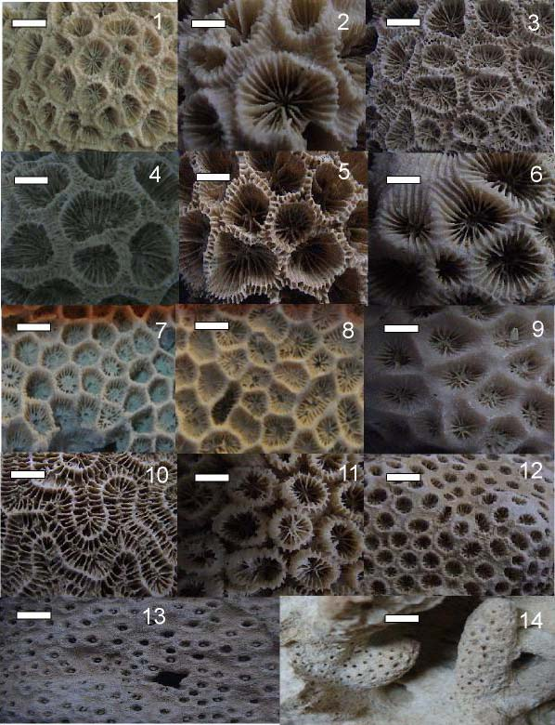

Fig. 2. Fossil corals collected from an uplifted area at Ras Gunz near Jiwani, Balochistan coast.
1) Favia truncatus? (bar= 12mm); 2) F. lizardensis (bar = 10mm); 3) Favia sp. 1 (bar = 15mm); 4) Favia sp. 2 (bar = 12mm); 5) Favia sp. 3 (bar = 14mm); 6) Favia sp. 4 (bar = 15mm); 7) Favites cf. acuticollis (bar = 7mm); 8) Favites sp. (bar = 8mm); 9) Goniastrea cf. retiformis (bar = 10mm); 10) Platygyra daedalea (bar = 6mm); 11) Cladocora cf. caespitosa (bar = 6mm); 12) Cyphastrea serailia (bar = 3mm); 13) Astreopora sp. (bar = 4mm); 14) Acropora sp. (bar = 1mm).

Favites cf. acuticollis
Colonies are encrusting. Corallites are circular, deep, cerioid, up to 7 mm in diameter with thick and sharp walls. Septa are few, widely spaced, in 2 orders and have a considerable distance between. The larger septa fuse with fully developed columella. Pali almost absent. This species resembles to Favites pentagona but has less pentagonal corallites.
Favites sp.
Colonies are encrusting. The corallites are variable in shapes, some are in short valleys, ranging in size from 6 to 8 mm. Septa are fine, numerous, widely spaced and fuse with fully developed columella. Pali inconspicuous. It is possible that this species might be Goniastrea since many characters are invisible due to the process of burial.

Goniastrea cf. retiformis
Corallites are 4 to 10 mm in diameter, slightly angular and have thick walls. Septa are in 2 orders, the larger reaches solid columella. Pali poorly developed.

Platygyra daedalea
Colonies are meandroid. The valleys are about 4 to 6 mm in diameter and the columella which is poorly developed, run continuously in the centre of valleys. The septa are fine, exsert, and the walls of the corallites are sharp.

Cladocora cf. caespitosa
The colonies are plocoid with tubular corallites. The compacted corallites have a diameter of 4 to 6 mm. Septo-costae well developed. The septa are in two orders and the first reach to the fully developed columella. Pali inconspicuous.

Cyphastrea serailia
Colonies massive. Corallites are plocoid to sub-plocoid, 3mm in diameter and conical in shapes. The corallites are widely spaced but at most part of the colony they are crowded. The septa are fine and occur in 2 cycles. The surrounding coenosteum is granulated.

Astreopora sp.
Colonies are encrusting. The corallites are 2 to 4 mm in diameter and moderately immersed. They are rounded in shape. Septa are numerous and fused with a spongy columella.

Acropora sp.
Colonies have finger like upright branches. Radial corallites are variable in size, not exceed more than 1 mm in diameter and deep. The coenosteum is porous. The septa are in two cycles. The secondary septa are rudimentary type while the primary septa are 6 in number and fuse with columella.

DISCUSSION

Fourteen fossil corals species belong to 2 families and 8 genera were recorded. During the process of burial many characters like septa, paliform lobes and septal dentation used in identification have been lost. This limits the identification of some specimens only to genus level. None of the fossilized corals identified in this study, are represented within the modern distribution of coral species (Ali, 2008), and it appears that almost all of the corals found in the Pleisotcene are extinct. Among the fossilized corals, members of family Faviidae (especially genus Favia) were most diverse and abundant. Conversely, present studies at 18 dive sites along Balochistan and Sindh coasts (Ali, 2008), revealed no species of Favia. The disappearance of Favia is quite surprising as this species is known to tolerate high sedimentation environments by virtue of having large size calices (>10 mm), which may help in rejecting sediment more easily than species with smaller calices (Stafford Smith and Ormond, 1992). Individual species of coral have resistance to sediment stress up to certain critical levels. There are differing tolerances to sediment levels among coral species (Fabricius, 2005). For example, Porites are more tolerant to sediments load than Favia (Stafford-Smith, 1993). Luckge et al. (2001) have shown that fluvial input from 5000 to 3000 years BP increased due to climatic and hydrological changes in this area. Lithogenic fluxes derived from Makran were highest during the period of Pleistocene and the sediment load increased as a result of uplifting and sea level fluctuations. Hence it may be possible that Favia could not survive due to increase in sedimentation load.
Therefore, it is possible that late Pleistocene uplifting and sea level fluctuations may have caused habitat loss. Present day anthropogenic input of pollution may have rendered the environment less favorable for corals, especially for Favia.
Although the number of species reported here in our studies is small, it provides evidence for recent extinctions in the Makran region of Pakistan. Considering the diversity of fossil coral fauna presented in this paper, it is likely that future surveys at other places along Balochistan coast will help in finding new fossal coral species.

ACKNOWLEDGEMENTS

Support from DeLPHE project funds (project # 82) to PJAS is thankfully acknowledged. Authors are indebted to Prof. Dr. Athar Ali Khan, Dept. of Geology, University of Karachi for help in the preparation of manuscript.

REFERENCES

ALI, A., 2008. Distribution and diversity of corals and reef associated fauna inhabiting coastal waters of Pakistan. M.Phil. thesis, Center of Excellence in Marine Biology, University of Karachi, Karachi Pakistan, pp. 100.
ALI, S.I.U. AND MEMON, G.M., 1995. Environmental geology of the Pakistan coast and its influence on corals, oysters, and mangroves. In: The Arabian Sea. Living marine resources and the environment (eds. M. F. Thompson and N. M. Tirmizi), Lahore, Pakistan. Vanguard Books (Pvt.) Ltd. pp. 575-585.
CRAME, J. A., 1984. Neogene and Quaternary Mollusca from the Makran Coast, Pakistan. In: Marine geology and oceanography of Arabian Sea and coastal Pakistan. ISBN 0-442-23216-0: pp. 45-57
FABRICIUS, K.E., 2005. Effects of terrestrial runoff on the ecology of coral and coral reefs. Review and synthesis. Mar. Pollut. Bull., 50: 125-146.
HARMS, J.C., CAPPEL, H.N. AND FRANCES, D.C., 1984. The Makran Coast of Pakistan: its stratigraphy and hydrocarbon potential. In: Marine geology and oceanography of Arabian Sea and coastal Pakistan. ISBN 0-442-23216-0: pp. 1-25
LUCKGE, A., DOOSE-ROLINSKI, H., KHAN, A.A., SCHULZ, H. AND VON RAD, U., 2001. Monsoonal variability in the northeast Arabian Sea during the past 5000 years. Geochemical evidence from laminated sediments. Palaeogeogr. Palaeoclimatol. Palaeoecol., 167: 273-286.
STAFFORD-SMITH, M.G., 1993. Sediment rejection efficiency of 22 species of Australian scleractinian corals. Mar. Biol., 115: 229-243.
STAFFORD-SMITH, M.G. AND ORMOND, R.F.G., 1992. Sediment-rejection mechanisms of 42 species of Australian Scleractinian corals. Aust. J. Mar. Freshw. Res., 43: 683-705.
VERON, J., 2000. Corals of the world. Australian Institute of Marine Science, CCR Old Ptv Ltd., Townsville.

(Received 12 July 2010, revised 4 August 2010)

